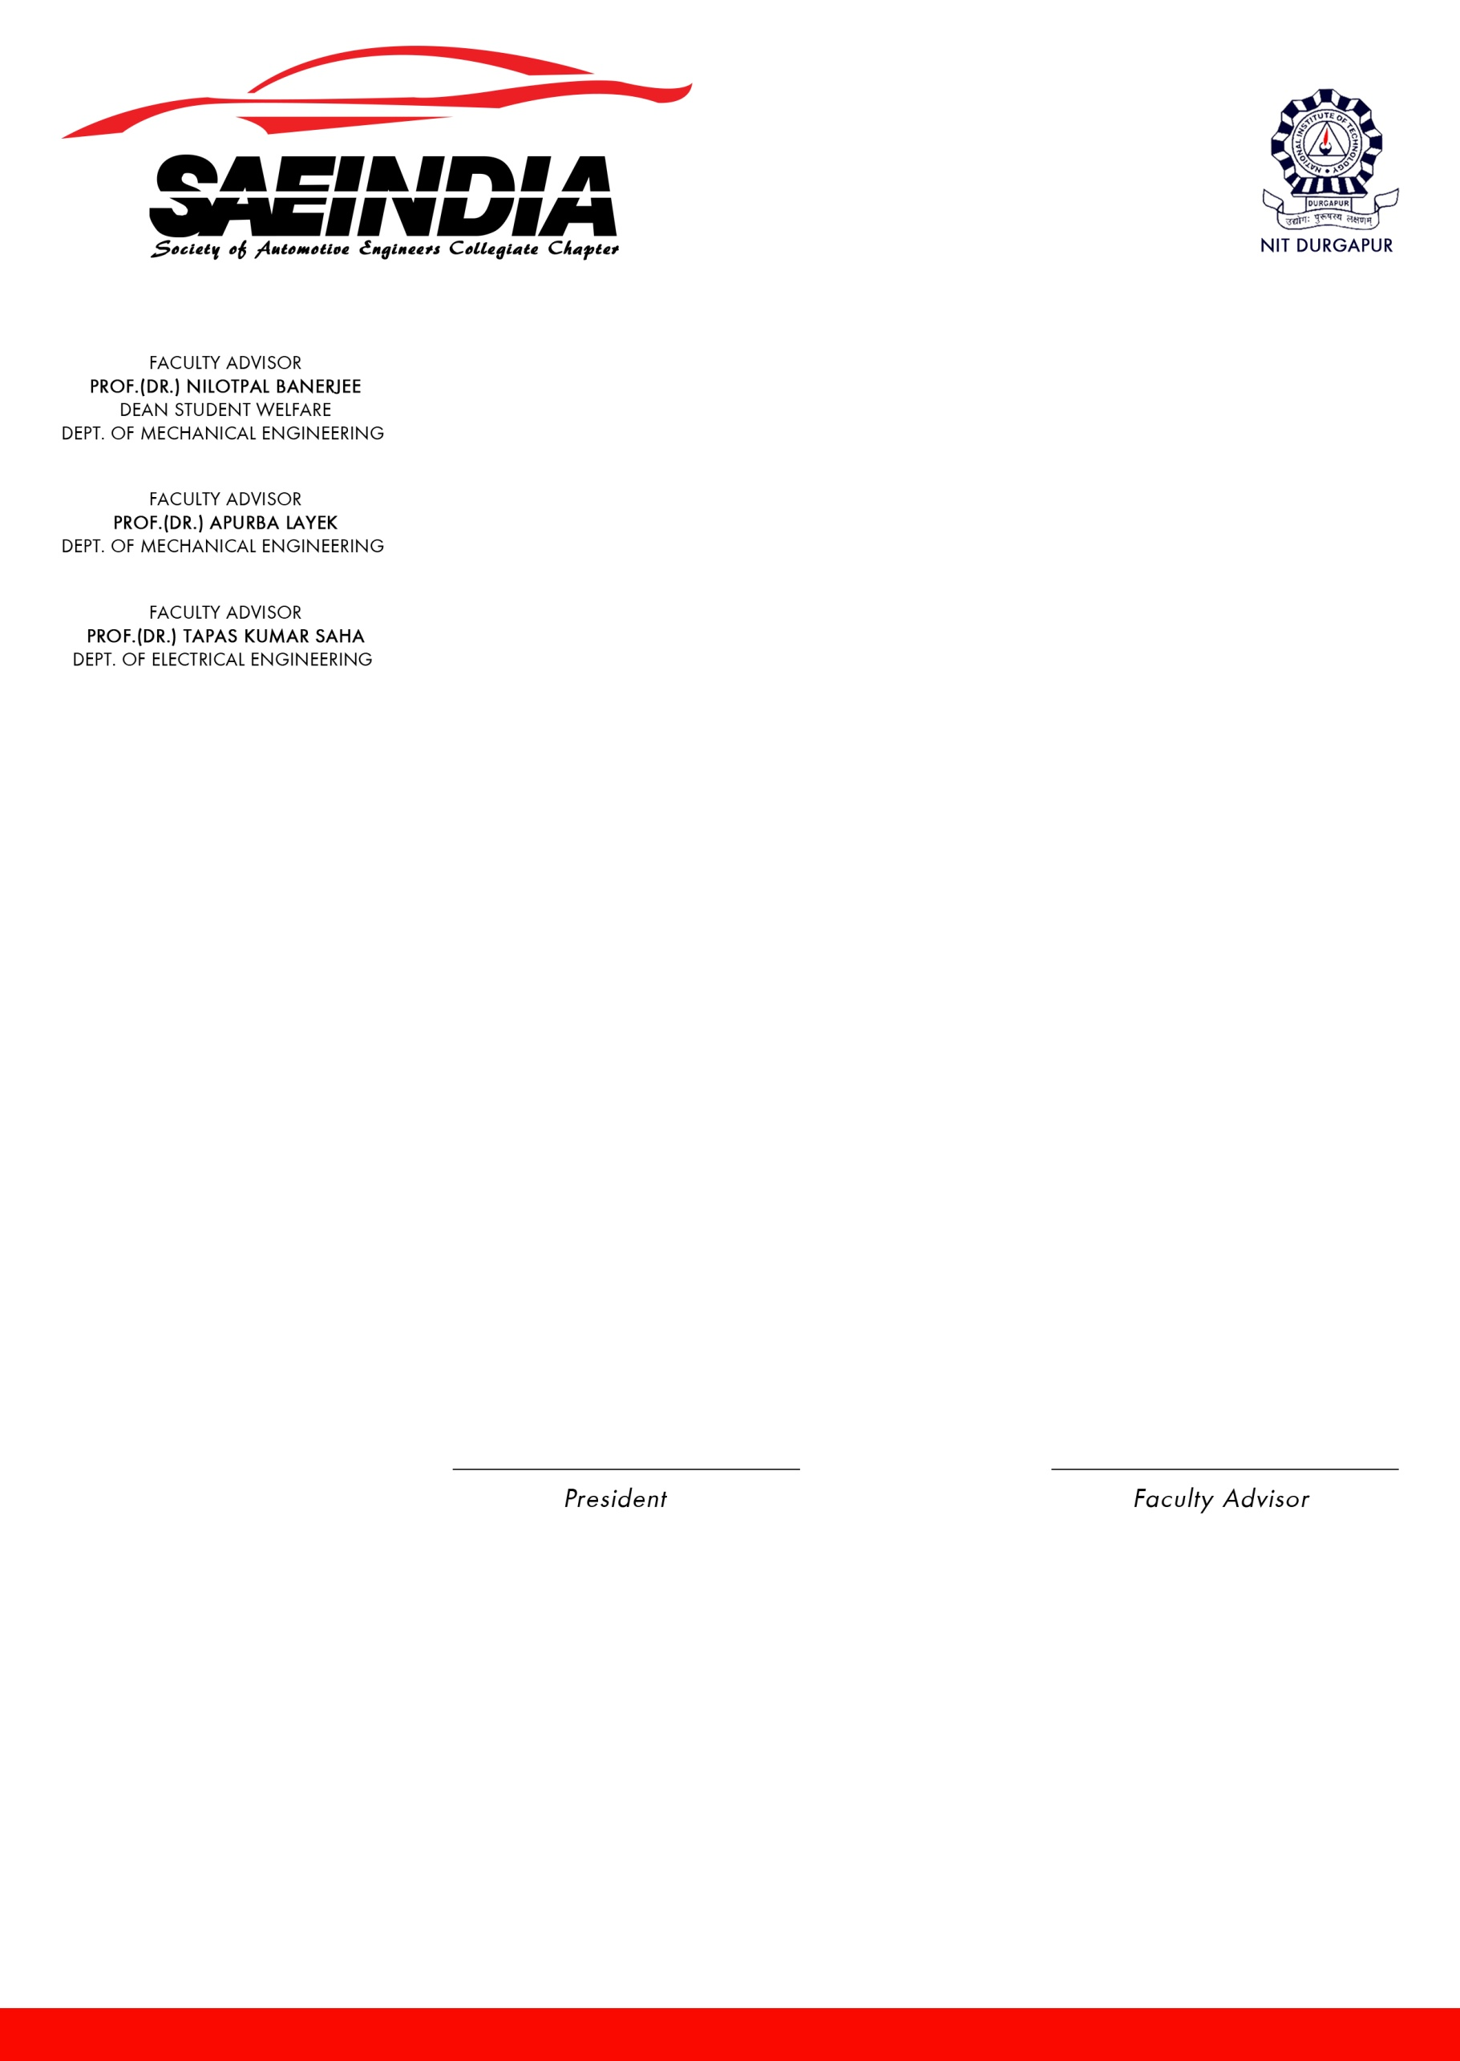

**List of position holders.**

|  |  |  |
| --- | --- | --- |
| Position | Name | Signature |
| President | E. Arvind Satya |  |
| Vice President | Rajat Mishra |  |
| General Secretary | Shubham Singh |  |
| Assistant General Secretary | Trishul Paul Choudhary |  |
| Convenor | Ananya Roy |  |
| Co-convenor | Supriya Sinha |  |
| Treasurer | K. Vikram Reddy |  |
| Technical Head | Anuj Maurya |  |
| V.V.S. Narayana Murthy |  |
| Fest Coordinator | Meghana Bandaru |  |
| Creative Head | Antham Sai Lekha |  |
| Design Head | Ajitabh Das |  |
| BAJA Coordinator | Ravi Shankar Ram |  |
| BAJA Captain | Sagnik Dutta |  |
| BAJA Vice-Captain | Nethi Vinay Kumar |  |